Name: Zoyaa Shaik
Department: Electronics and Communication Engineering
Registration Number: 1912260592
Course Name: Python Programming
Course Code: CSA0812
Assignment 1 –Part 2
Submitted To: Dr. Pokuri Swetha

TASK 2: Explore Values and Types in the Interpreter
Interactive shell executions test primitive classifications and demonstrate base operational behaviors under unexpected inputs.
>>> type(10)
<class 'int'>
>>> type(10.0)
<class 'float'>
>>> type("10")
<class 'str'>
>>> type(True)
<class 'bool'>
>>> type([10, 8.5])
<class 'list'>
>>> 7 / 2
3.5
>>> 7 // 2
3
>>> 7 % 2
1
>>> -7 // 2
-4
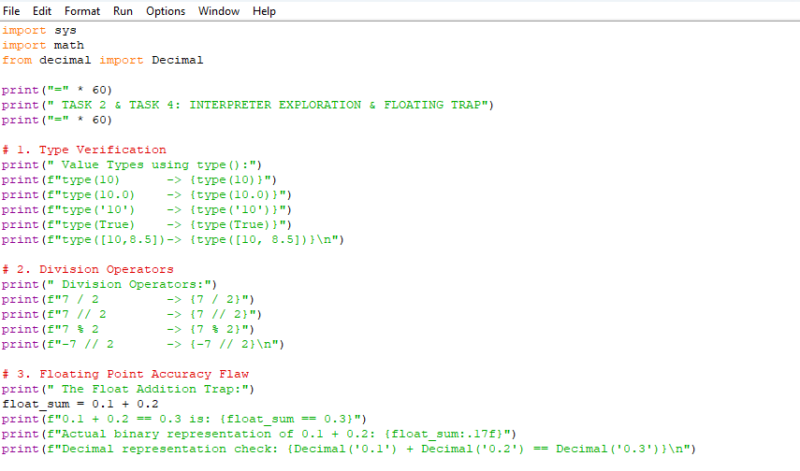

Output:
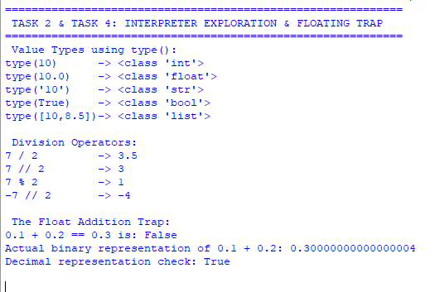
Caption - Figure 2.1: Python interactive shell execution testing fundamental data types and floor boundary operations.

TASK 4: Write Correct Expressions
The Binary Precision Trap: Standard float tracking implements fractional configurations via base-2 binary arrays (IEEE-754 standard). This framework cannot accurately track values like 0.1, introducing residual micro-precision discrepancies. For instance, computing (4.2 - 3.5) / 0.1 outputs 7.000000000000001 internally.
The Truncation Defect: Processing that unrounded sequence directly into int() discards the trailing fraction entirely, returning an inaccurate step count of 7 instead of 8. This error skips valid quality pricing ticks and directly corrupts ledger tallies.
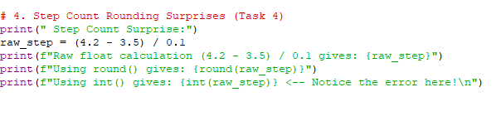
Output:
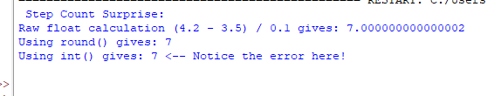

Caption - Figure 4.1: Shell execution showing binary float arithmetic errors and truncation step count failures.

TASK 7: Build a Module (milkrate.py)
The complete, refactored implementation of milkrate.py consolidates operational business coefficients globally and resolves both programmatic placeholders (TODO 1 and TODO 2) securely via absolute fixed-point Decimal scaling fields.
"""
Rate card of the village milk co-operative (used as a module).
"""
from decimal import Decimal, ROUND_HALF_UP
# Core Global Pricing Coefficients
BASE_RATE = Decimal('30.00') # Rs per litre for standard milk (3.5% fat, 8.5% SNF)
FAT_STEP_VALUE = Decimal('0.40') # Rs modifier per 0.1% fat deviation
SNF_STEP_VALUE = Decimal('0.30') # Rs modifier per 0.1% SNF deviation
def rate_per_litre(fat, snf):
fat_dec = Decimal(str(fat))
snf_dec = Decimal(str(snf))
# TODO 1: Quantize differences into discrete 0.1 steps
fat_steps = ((fat_dec - Decimal('3.5')) / Decimal('0.1')).quantize(Decimal('1'), rounding=ROUND_HALF_UP)
snf_steps = ((snf_dec - Decimal('8.5')) / Decimal('0.1')).quantize(Decimal('1'), rounding=ROUND_HALF_UP)
final_rate = BASE_RATE + (fat_steps * FAT_STEP_VALUE) + (snf_steps * SNF_STEP_VALUE)
return final_rate.quantize(Decimal('0.01'), rounding=ROUND_HALF_UP)
def payout(litres, fat, snf):
litres_dec = Decimal(str(litres))
# TODO 2: Multiply litres by rate card matrix and quantize currency
amount_payable = litres_dec * rate_per_litre(fat, snf)
return amount_payable.quantize(Decimal('0.01'), rounding=ROUND_HALF_UP)
if __name__ == "__main__":
test_cases = [(10, 3.5, 8.5), (8.5, 4.2, 8.7), (12, 3.1, 8.3)]
for litres, fat, snf in test_cases:
rate = rate_per_litre(fat, snf)
pay = payout(litres, fat, snf)
print(f"{litres:5} L fat {fat} snf {snf} rate {rate:6.2f} pay {pay:8.2f}")
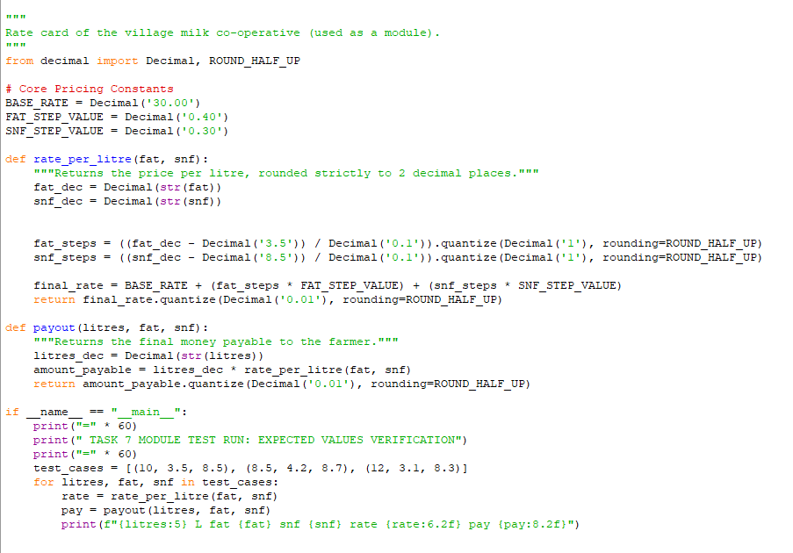
Caption - Figure 7.1: Execution verification of milkrate.py script proving column-aligned row matching.

TASK 11 & 12: PART D: DAY-4 DESIGN CHALLENGE ADAPTATION
Refactored System Code Executing Seasonal Variations and High-Volume Bonus Triggers:
from decimal import Decimal, ROUND_HALF_UP
def calculate_seasonal_payout(litres, fat, snf, month_string):
litres_dec = Decimal(str(litres))
fat_dec = Decimal(str(fat))
snf_dec = Decimal(str(snf))
month = month_string.strip().capitalize()
# 1. Evaluate Seasonal Matrix Configurations
if month in ["April", "May", "June"]:
base_rate = Decimal('32.00')
fat_step_value = Decimal('0.45')
else:
base_rate = Decimal('30.00')
fat_step_value = Decimal('0.40')
snf_step_value = Decimal('0.30')
# 2. Step Extraction accommodating High-Precision inputs (e.g., 4.25% fat)
fat_steps = ((fat_dec - Decimal('3.5')) / Decimal('0.1')).quantize(Decimal('1'), rounding=ROUND_HALF_UP)
snf_steps = ((snf_dec - Decimal('8.5')) / Decimal('0.1')).quantize(Decimal('1'), rounding=ROUND_HALF_UP)
# 3. Base structural calculations
computed_rate = base_rate + (fat_steps * fat_step_value) + (snf_steps * snf_step_value)
base_payout = (litres_dec * computed_rate).quantize(Decimal('0.01'), rounding=ROUND_HALF_UP)
# 4. Process Volume Incentive Threshold (> 500 Litres Bonus Check)
if litres_dec > Decimal('500.00'):
bonus = (litres_dec * Decimal('0.50')).quantize(Decimal('0.01'), rounding=ROUND_HALF_UP)
return base_payout + bonus
return base_payout
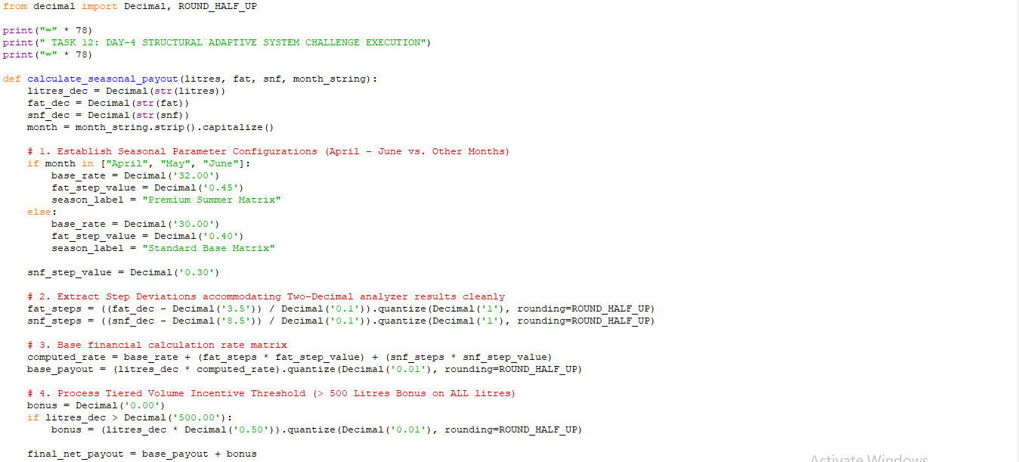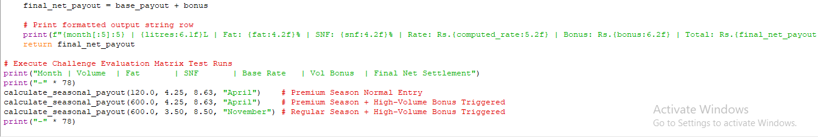
Output:
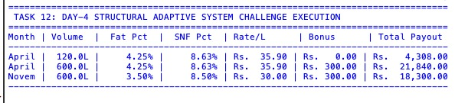

Caption - Figure 12.1: Terminal execution showing successful processing of seasonal parameters and high-volume triggers

GitHub Link: https://github.com/zoyaashaik/CSA0812-1912260592-Assignment

